[Project Progress on E-Commerce](https://www.researchgate.net/publication/304703920_A_Review_Paper_on_E-Commerce?enrichId=rgreq-e186b1fee05790415c0d520f28a8f305-XXX&enrichSource=Y292ZXJQYWdlOzMwNDcwMzkyMDtBUzozNzkzMDc1Njc0MDMwMDhAMTQ2NzQ0NTM3OTQwOQ%3D%3D&el=1_x_3&_esc=publicationCoverPdf) Website

**E-commerce Website Name:**

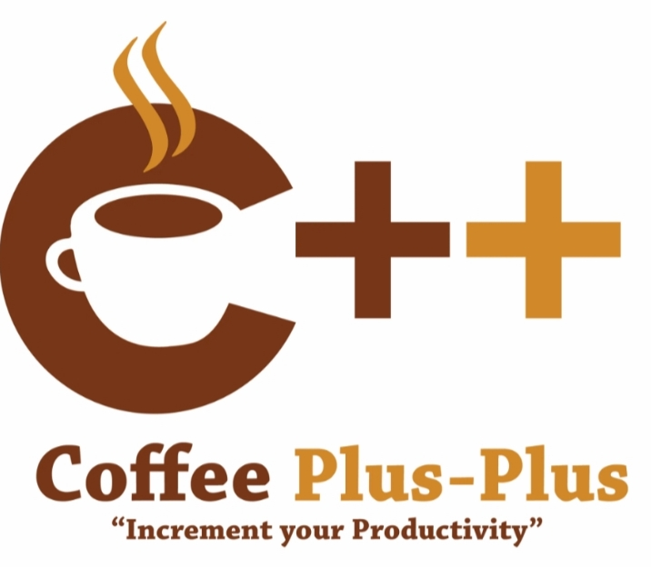

**Members:**

Gonzales, Kenneth

Lisaba, Rose Ann

Morcoso, Mary Joyce

Saunar, Maricon

February 2023

**Progress Report**:

During the first and second weeks of class, the members started discussing ideas for the project and familiarizing themselves with different programming languages. They also began creating preliminary drafts for the website, including drafts for the login/register system. Our group has been working hard to develop and implement the necessary features and functionality to ensure the success of our project.

**✓ WEBSITE DESIGN:**

The objective of our e-commerce website design was to convey the essence of the coffee shop, which serves high-quality coffee, in a visually appealing way.

To begin the design process, we conducted research on the coffee industry and various coffee website design to get an idea of what elements are commonly used in coffee online store. We also considered the target audience, who were coffee lovers and connoisseurs, and their preferences.

Next, we created several rough sketches and drafts, taking into account the desired color palette, typography, and imagery. The sketches were then reviewed and refined, with the team considering feedback and making changes as needed.

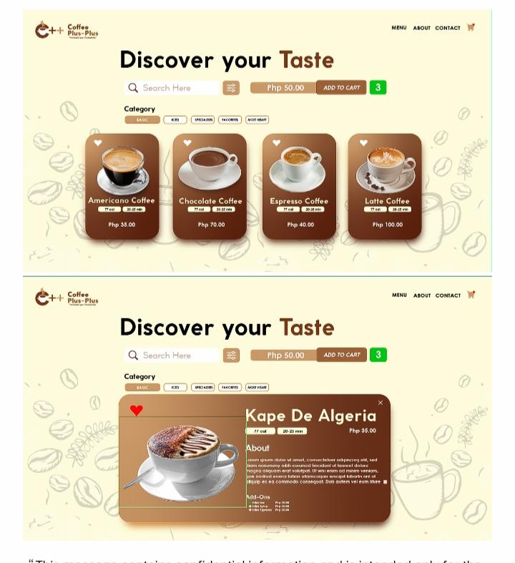After several rounds of revisions and feedback, our final E-commerce Website Design was completed. The design creation process was a collaborative effort, with the team working together to ensure that the final product conveyed the desired message and met the needs of the client.

**✓ TURNING A LAYOUT WEBSITE DESIGN INTO A WORKING WEBSITE**

This process involved several steps, which we outline below.

First, Mr. Kenneth Gonzales created the structure of the website using HTML. HTML provided the basic structure for the page, such as headings, paragraphs, lists, images, links, and other elements. He used **HTML** to define the layout of the page, including where each element would appear and how it would be organized.

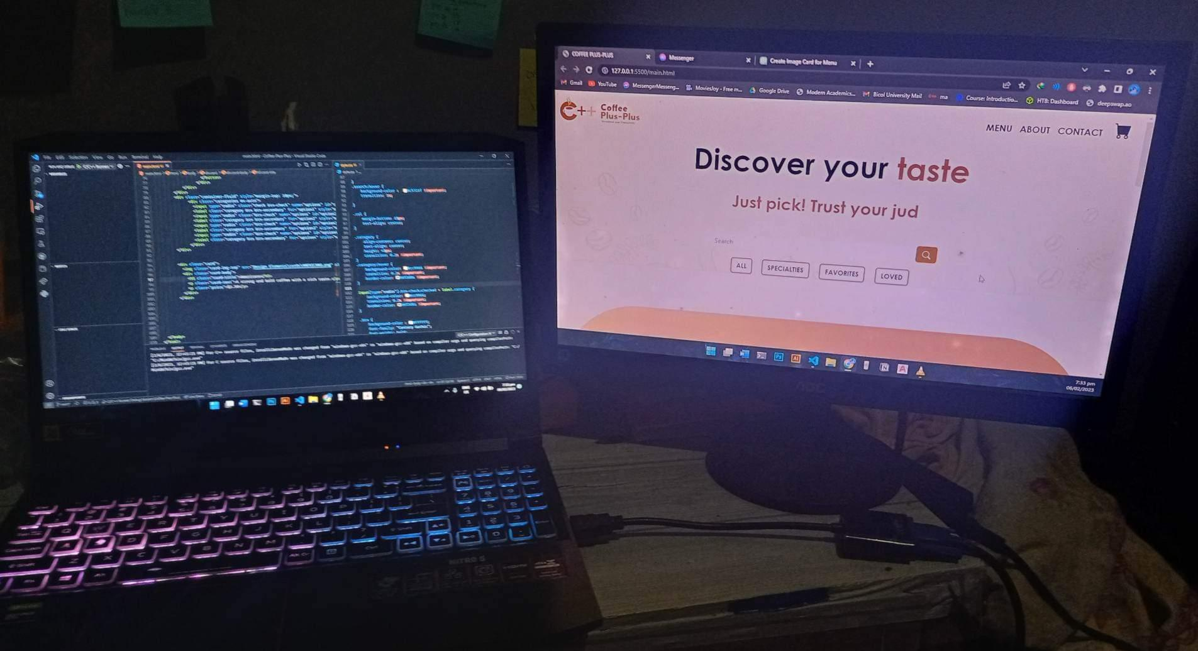

Next, we used **CSS** to style the HTML elements and make the website look the way it was intended to. We used CSS to control the look and feel of the website, including things like color, fonts, spacing, and other design elements. With CSS, we was able to create a unique and visually appealing design that would engage the audience and help the website stand out.

If interactive elements were to be added to the website, such as animations, forms, and user input validation, we used **JavaScript**. JavaScript allowed for the creation of dynamic and interactive experiences for the users, making the website more engaging and useful.

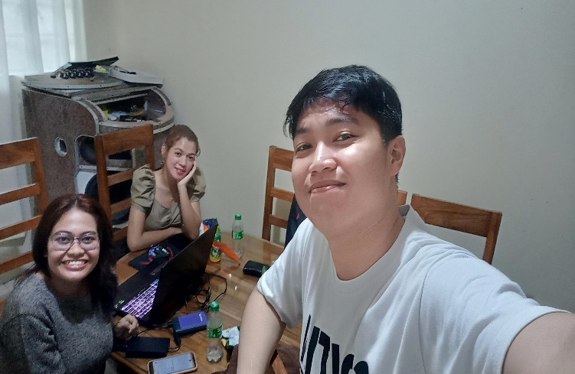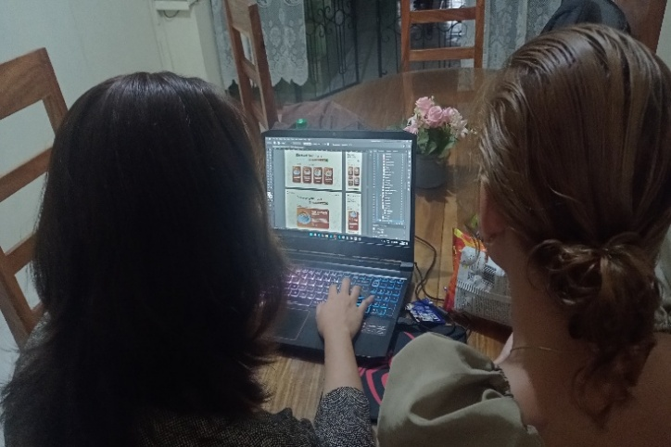

With the structure and style of the website in place, we added the actual content. This included text, images, videos, and other media that would be displayed on the website. We made sure the content was well-written, engaging, and relevant to the target audience.

**✓ BASIC FLOWCHART OVERVIEW OF THE WORKING WEBSITE:**

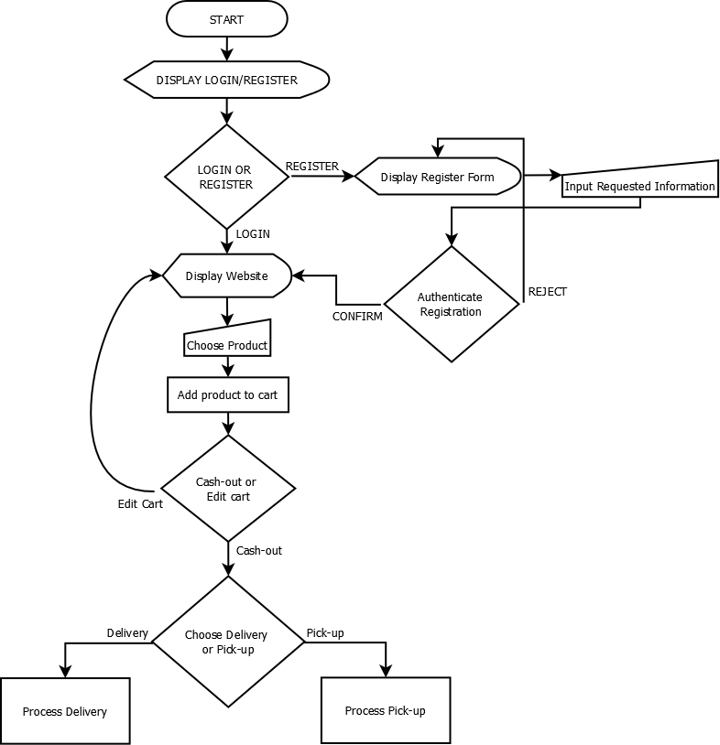

**✓ SOFTWARE DEVELOPMENT LIFE CYCLE (SDLC) MODELS:**

The group had decided to use the **Agile Models** for the project. Agile was a popular method for software development that emphasized flexibility, collaboration, and rapid iteration.

Using Agile, the team was able to break the project down into smaller, manageable parts, or sprints. This allowed for frequent check-ins with the customer, and the ability to quickly adjust to changes as needed. The members was able to work collaboratively, with regular meetings and open communication, to ensure that everyone was on the same page and the project was moving in the right direction.

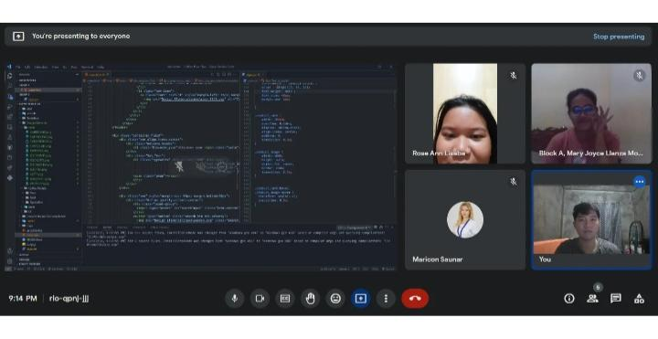With the Agile methodology, the group was able to create a high-quality website that met the needs of the customer, in a fast and efficient manner. The customer was satisfied with the outcome, and the team was proud of the work they had accomplished using the Agile methodology.

**UPDATE:**

Currently, each member of the team has been assigned a specific task to work on as partcommerce website development project. Each member is responsible for fulfilling a specific role in order to ensure the successful completion of the project.

**Task 1: Website Design And Project Management**

Mr. Kenneth Gonzales of the team has been working on the design of the website. He was responsible for creating a visually appealing and user-friendly interface that will allow users to easily navigate the website. He is also responsible for setting the direction of the project and ensuring that the team is on track to meet the deadlines. He has been monitoring the progress of the project and making any necessary adjustments to ensure that the website is completed on time.

**Task 2: Documentation and Features of the Website**

Ms. Mary Joyce Morcoso and Maricon Saunar have been assigned the responsibility of handling the documentation and functionality aspects of the website. They been working on creating detailed specifications and user requirements to ensure that the website meets the expectations of the customers. They been ensuring that all the features of the website are well documented so that the other members of the team are aware of what is expected of them.

**Task 3: Gathering Information on E-Commerce Websites**

Ms. Maricon Saunar has been working on gathering information and knowledge about how e-commerce websites work. She has been researching the best practices and strategies for building successful e-commerce websites. The information gathered has been helpful in ensuring that the website being developed is user-friendly.

**Task 4: Login and Register Systems**

Ms. Rose Ann Lisaba has been working on the login and register systems of the website. She has been developing secure and efficient systems to ensure that the website is able to protect the personal information of its users.

The team has been working hard to ensure that the e-commerce website being developed meets the objectives of the project. The members have been communicating and collaborating effectively to ensure that the project is completed on time and to a high standard.

The project is making progress, as some parts of the module have already been started.